INFO 3300

Professor Peña

10/05/2024

**DATA WAREHOUSING**

**COURSE PROJECT – PART 1**

1. **Project Proposal**
   1. **Introduction:**

MoonGlim Jewelry is a luxury jewelry and accessories brand dedicated to delivering the highest-quality gemstones, precious metals, and pearls. As a Direct-to-Consumer (D2C) company, we offer pre-designed pieces that are available both in-store and online.

**Who We Serve:**

MoonGlim Jewelry serves customers who prioritize convenience and seek sophisticated, ready-to-wear pieces that embody elegance and exclusivity. Our clients value high-quality craftsmanship and designs that are made specifically for their needs.

**Short-Term Goals:**

Our short-term goal is to use our data warehouse to expand our customer base by providing actionable insights for targeted marketing and enhancing customer experience. By using employee, customer, product and date data in connection with orders our goal is to be able to more clearly analyze what affects our sales and revenue so we can make actionable decisions that will improve them.

**Long-Term Goals:**

Our long-term goal is to increase revenue by 20% and expand MoonGlim Jewelry with the opening of a new location. Even with this growth we want to remain dedicated to sustainability and ethical sourcing, ensuring each piece reflects both luxury and responsibility. By leveraging our data warehouse to analyze customer preferences, product performance, and operational efficiency, we can make data-driven decisions that will support our growth, elevate customer experiences, and solidify our reputation as a leader in quality and ethical jewlery sales within the luxury jewelry market.

* 1. **Description of the project**

Our data mart will focus on sales data, allowing specific departments or teams to quickly access the information they need within the larger data warehouse. It will include key data like customer details, employee information, product data, and order history. By making this data more accessible, the teams can more easily gather and analyze it for marketing and sales purposes. This project will be the first step toward building a larger data warehouse, providing a more efficient way for teams to work with the data and make informed decisions that drive business growth.

* 1. **High-level diagram of the data mart, with the fact table, dimensions, and grain.**

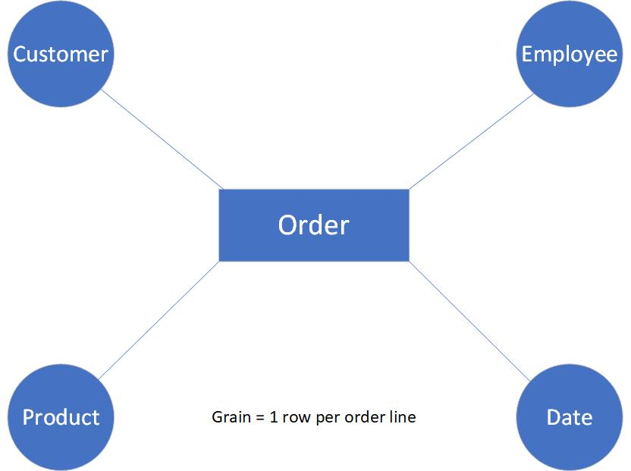

* 1. **At least 4 high-level KPIs or strategic metrics the data mart will provide, such as Total Revenue or Number of Customers Served.**
     1. Total Revenue to Date
     2. Average Order Amount (in dollars)
     3. Total Orders to Date
     4. Sales Growth Rate (Year over year)
  2. **Business requirement questions**
     1. The CEO would like to know the total revenue by year and quarter.
     2. The product manager wants to know which products are the least popular among customers.
     3. The product manager wants to know which product type generates the most revenue.
     4. The CCO wants to know which products are most popular in each state.
     5. The head of marketing wants to know who the most loyal customers are.
     6. The CFO wants to know which states generate the most revenue, broken down by product type.
  3. Wireframe of dashboard you will develop once the data mart is populated. The wireframe should be developed with a particular stakeholder audience in mind, such as C-suite officers. Introduction that addresses the background of the business, such as “who we are”.
     1. We will be presenting this dashboard to the CFO and other higher ups within the Finance department. In addition we will be presenting this dashboard to members of the Sales Department. The goal is for them to gain more knowledge on the factors that affect profit. Both teams will be able to use this data to make business decisions that will help the company continue to grow.
     2. 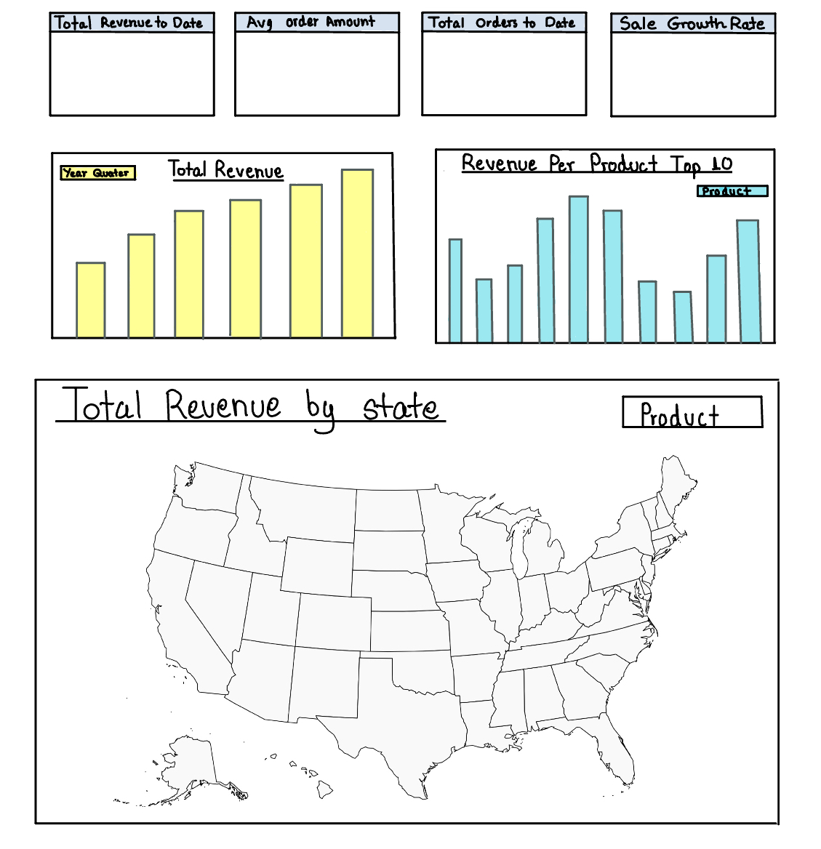

1. **Information Package**

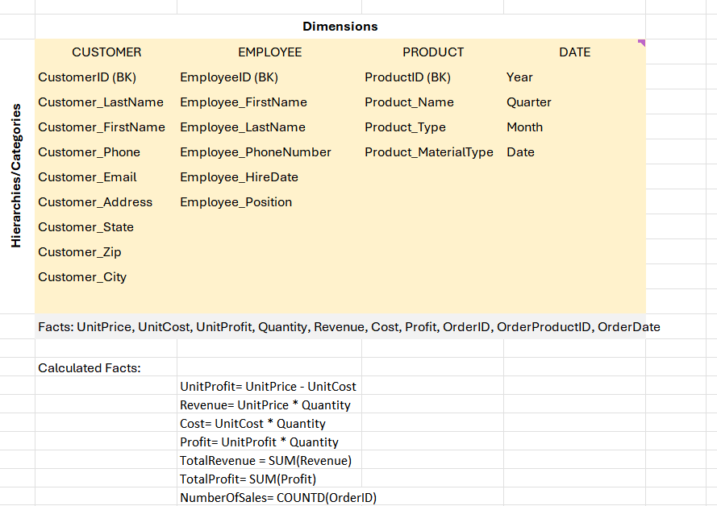

1. **Star Schema**
   1. 1 business process
   2. 1 fact table
   3. At least 4 dimension tables, including the date dimension

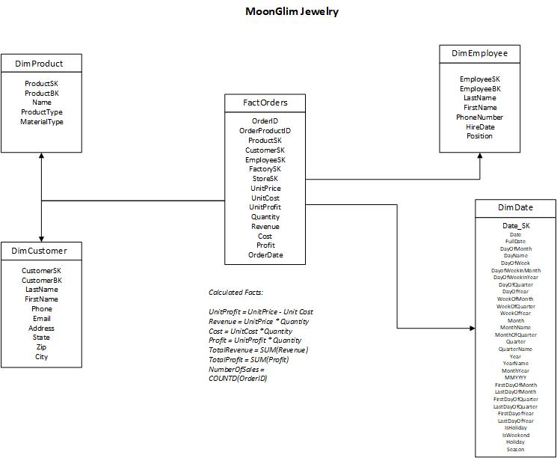

SUBMISSION

You will submit four files for this part of the project:

Data mart proposal (BusinessName – Proposal.docx)

Information package (BusinessName – Information Package.xlsx)

Star schema (BusinessName – Star Schema.vsdx)